Software Requirement Specification

Automated Facial Recognition Attendance System

Project Code:
AFAS-2024

Internal Advisor:
Mr. Farooq Javeed

Project Manager:
Dr. Muhammad Ilyas

Project Team:
Muhammad Zakaria Masood (Team Lead)
Zill E Haseeb (Member)

Submission Date:

November 10, 2023

_____________________
Project Manager’s Signature
Document Information

Category | Information
Customer | SU
Project | Automated Facial Recognition Attendance System
Document | Requirement Specifications
Document Version | 1.0
Identifier | Sweet_Stalker_AFAS-2024
Status | Draft
Author(s) | Muhammad Zakaria Masood  Zill E Haseeb
Approver(s) | PM
Issue Date | Nov. 10, 2023
Document Location
Distribution | - Advisor  - PM  - Project Office

Definition of Terms, Acronyms and Abbreviations
This section should provide the definitions of all terms, acronyms, and abbreviations required to interpret the terms used in the document properly.

Term | Description
ASP | Active Server Pages
SRS | Software Requirements Specifications
DBMS | Database Management System

Table of Contents

1. Introduction 4
1.1 Purpose of Document 4
1.2 Project Overview 4
1.3 Scope 4
2. Overall System Description 5
2.1 User characteristics 5
2.2 Operating environment 5
2.3 System constraints 6
3. External Interface Requirements 6
3.1 Hardware Interfaces 7
3.2 Software Interfaces 7
3.3 Communications Interfaces 8
4. Functional Requirements 8
5. Non-functional Requirements 8
5.1 Performance Requirements 8
5.2 Safety Requirements 8
5.3 Security Requirements 8
5.4 User Documentation 9
6. Assumptions and Dependencies 9
7. References 9

- Introduction
This software requirements specification (SRS) document aims to provide guidelines and specifications for the design and development of an artificial intelligence (AI)-based attendance system that makes use of face recognition technology.
  - Purpose of Document
This SRS document serves to specify the goals, parameters, and functional specifications for the AI-based attendance system. It intends to give a clear picture of the features, capabilities, and limitations of the system in order to direct development and guarantee alignment with project objectives.

  - Project Overview
The AI-based attendance system is an application of software that makes use of face recognition technology to completely transform attendance tracking. It will be utilized for precise and effective tracking in business and educational organizations. In addition to offering a use-friendly interface for people to register their facial biometrics, the system will evaluate real-time facial photos using deep learning algorithms and compare them with profiles that have already been pre-enrolled.
Administrators will be able to access and recover correct records due to the system’s safe storage and management of attendance data. The project’s objectives are to increase accuracy and dependability, reduce human effort, and automate the process. Benefits include less mistake, more efficient attendance management, better analytical and reporting capabilities, and better administrative decision-making. Real-time tracking of attendance records will be made possible by the AI-based attendance system, guaranteeing precise information for compliance reporting, performance reviews, and payroll processing.

  - Scope
The scope of the project includes the following:
- Functional Scope: The system will include functionalities such as facial biometric enrollment, real-time recognition, attendance data management, reporting and analysis. User will be able to register their facial biometrics easily, and the system will perform facial recognition for attendance tracking. Data will be securely stored and managed, comprehensive reports and analytics will be generated for administrators.
- Non-functional Scope: The system will prioritize performance, ensuring the ability to handle a large number of users and process facial recognition request in real-time. Security measures will be implemented to protect sensitive attendance data, including encryption, access control, and compliance with data privacy regulation. The system will feature a user-friendly interface for users to enroll their facial biometrics and access attendance records. Compatibility with commonly used hardware and software platforms will be ensured for seamless integration.

- Overall System Description
An overview of the context in which the system will be developed and utilized, including the expected users, limitations, assumptions, and dependencies, is given in the overall system description.

  - User characteristics
The AI-based attendance system is expected to be used by administrators of the organizations. They will have full access to the system and will be responsible to register the facial metrics of organization’s employee/students, manage and oversee the attendance tracking process. They will enroll user’s facial biometrics, view attendance records, generate reports.

  - Operating environment
The following elements will make up the unique context in which the AI-based attendance system will function:
- Hardware Platform: The system will be designed to operate on common hardware, such as servers, PCs, and suitable face recognition technological devices. To perform facial recognition tasks and safely maintain attendance data, the hardware should have the required computing power, memory, and storage.
- Operating System: The operating system on which the system has been designed to run, such as Windows, Linux, or macOS, will be specified. The particular needs and preferences of the organization will determine which operating system is used. Utilizing the characteristics and capabilities of the selected operating system, the system should be compatible with it.
- Software Components: The system may depend on various software programs and components to function effectively. These may include of facial recognition libraries, database management system, encryption algorithm and reporting tools. During the system design and development process, particular software components and versions will be determined upon, guaranteeing compatibility and smooth integration.

  - System constraints
The AI-based attendance system will subject to various constraints and limitations, including:
- Software constraints: The selection of software tools, frameworks, and libraries may be limited based on compatibility with the facial recognition algorithms and the desired functionality of the system.
- Hardware constraints: The system's performance is determined by available hardware resources like processor power, memory, and storage space, and should be designed to work efficiently within the target hardware's limitations.
- Legal constraints: The system should show privacy controls and user policy to the users. It must adhere to applicable laws and ensure the secure storage and handling of sensitive information.
- Environmental constraints: The system should be designed to adapt to different environmental condition, such as varying angle and facial expressions.
- User constraints: The system should be user-friendly considering the end-user’s needs and capabilities.

- External Interface Requirements
This section is intended to specify any requirements that ensure that the new system will connect properly to external components. A context diagram to illustrate the interaction between system and its external entities is below:
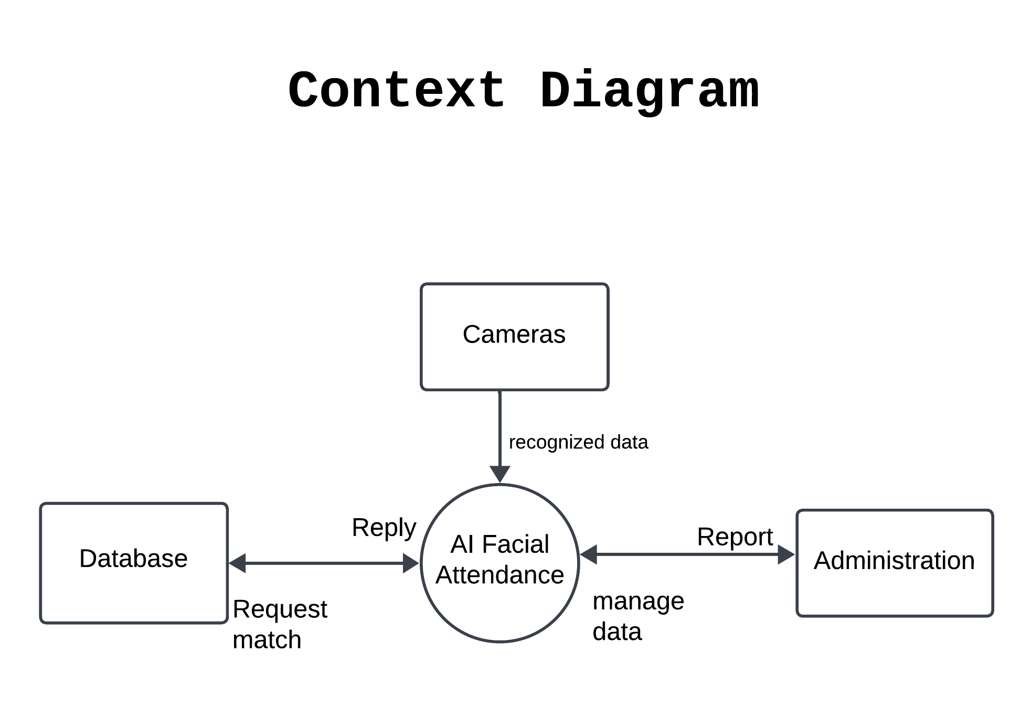
Figure 1, Context Diagram

  - Hardware Interfaces
The AI-based attendance system communicates with hardware components, especially Facial Recognition Devices. The hardware communicates with facial recognition devices in order to take real-time photos and perform facial recognition. The devices capture the image and transfer it to a server where the database will be setup. The administrator will control the system from his end point. The hardware interfaces provide for smooth communication between the AI-based attendance system and the Facial Recognition Devices, allowing for accurate and efficient attendance monitoring via facial recognition technology.

  - Software Interfaces
AI-based attendance system interacts with external software components such as databases, operating systems, tools, libraries, and integrated commercial components. It describes the goal of data exchange, the services required, the nature of inter-component contacts, and the data shared between these components. The AI-based attendance system may interact with the following software components:
- Database Management System: To store and manage attendance records, user information, and system configuration data, the system may require a database management system (DBMS). During the design and implementation phases, the specific DBMS, such as MySQL, PostgreSQL, or MongoDB, will be decided. To accomplish tasks such as data retrieval, storage, and updates, the system will interface with the DBMS.
- Operating System: The system will run on a certain operating system, such as Windows, Linux, or macOS. The operating system adopted will be determined by the organization. The system will interface with the operating system to conduct activities such as file management, process management, and allocation of system resources.
- Facial Recognition Library: The system may use a facial recognition library or API, such as OpenCV, Dlib, or FaceNet, to perform facial recognition tasks.
- Encryption Libraries: The system may utilize encryption libraries such as OpenSSL, or Cryptography to encrypt sensitive data like user-biometrics or attendance record that ensure the data security.
- Reporting Tools or Libraries: To create attendance reports and show attendance data, the system may use a reporting tool or library such as JasperReports or Microsoft Power BI.

  - Communications Interfaces
The system will make use of a variety of communication features, such as network connectivity, API integration, data transfer rates, and synchronizing methods. The system should be built to provide dependable and secure network connection using certain protocols and standards.

- Functional Requirements
Functional requirements outline What the system should do and support user activities in performing and completing tasks by using the proposed system, The list below shows the functional requirements of this project.
- The system shall allow new users to register and use the platform
- The system allows the user to log in by using username and password
- The system will encrypt the user passwords
- The system will be able to detect a human face from an image
- The system will be able to recognize faces based on existing data
- The system must be able to identify the students and mark them as attended
- The system must be able to update the attendance database based on attended students
- The system will only take attendance of the class based on when activated to do so
- The system will generate report of students from database.

- Non-functional Requirements
Non-functional requirements are system attributes, they constraints or restriction on the design of system and ensure the usability and effectiveness of the entire system.

  - Performance Requirements
- The system could be able to detect multiple faces at same time.
- The system will be available all day and perform processing efficiently.
- The system will create log to maintain the performance.

  - Safety Requirements
To prevent the system loss, protected actions will be implemented. To obtain data security, regular backups and secure storage are essentials. In case of an emergency or system failure, the system should include backup attendance marking mechanisms or emergency plans.

  - Security Requirements
To maintain the security of the system, data will be secure as encrypted like images because they are quite sensitive student’s data. User authentication and authorization will be maintained as user will be login with credentials and session will maintain that will be expire after some idleness.

  - User Documentation
User documentation helps users understand and effectively use the system. User manuals are comprehensive guidelines for system installation, configuration, and use, that will explain the system's features, workflows, and any necessary steps to perform various tasks.

- Assumptions and Dependencies
The success of the project is dependent on its ability to satisfy the objectives, which include hardware and network resources, training and testing data, and user collaboration. The project is dependent on a number of assumptions, including the availability of required infrastructure, data, a stable operating environment, user collaboration, external component integration, and third-party services.

- References
- Facial Recognition Algorithm and libraries. (n.d.). Retrieved from datagen: https://datagen.tech/guides/face-recognition/facial-recognition-algorithm/
- Iffandi, M. &. (2020). Attendance System with Face Recognition. In Software Engineering Perspectives in Intelligent Systems (pp. 1-7). Springer International Publishing.
- Omkar, A. S. (2017). Disguised Face Identification (DFI) with Facial KeyPoints using Spatial Fusion Convolutional Network. arXiv.
- Pros and Cons of Fog Computing Cameras. (n.d.). Retrieved from Boulder AI: https://boulderai.com/pros-and-cons-of-fog-computing-cameras/
- Semmler, C. (2014, October 20). Facial recognition is possible even if part of the face is covered. Retrieved from The Conversation: https://theconversation.com/facial-recognition-is-possible-even-if-part-of-the-face-is-covered-32812
- Vincent, J. (2017, Sept 7). TECH/ARTIFICIAL INTELLIGENCE/REPORT. Retrieved from TheVerge: https://www.theverge.com/2017/9/6/16254476/facial-recognition-masks-diguises-ai

